BULLETIN ANNOUNCEMENTS – ENGLISH

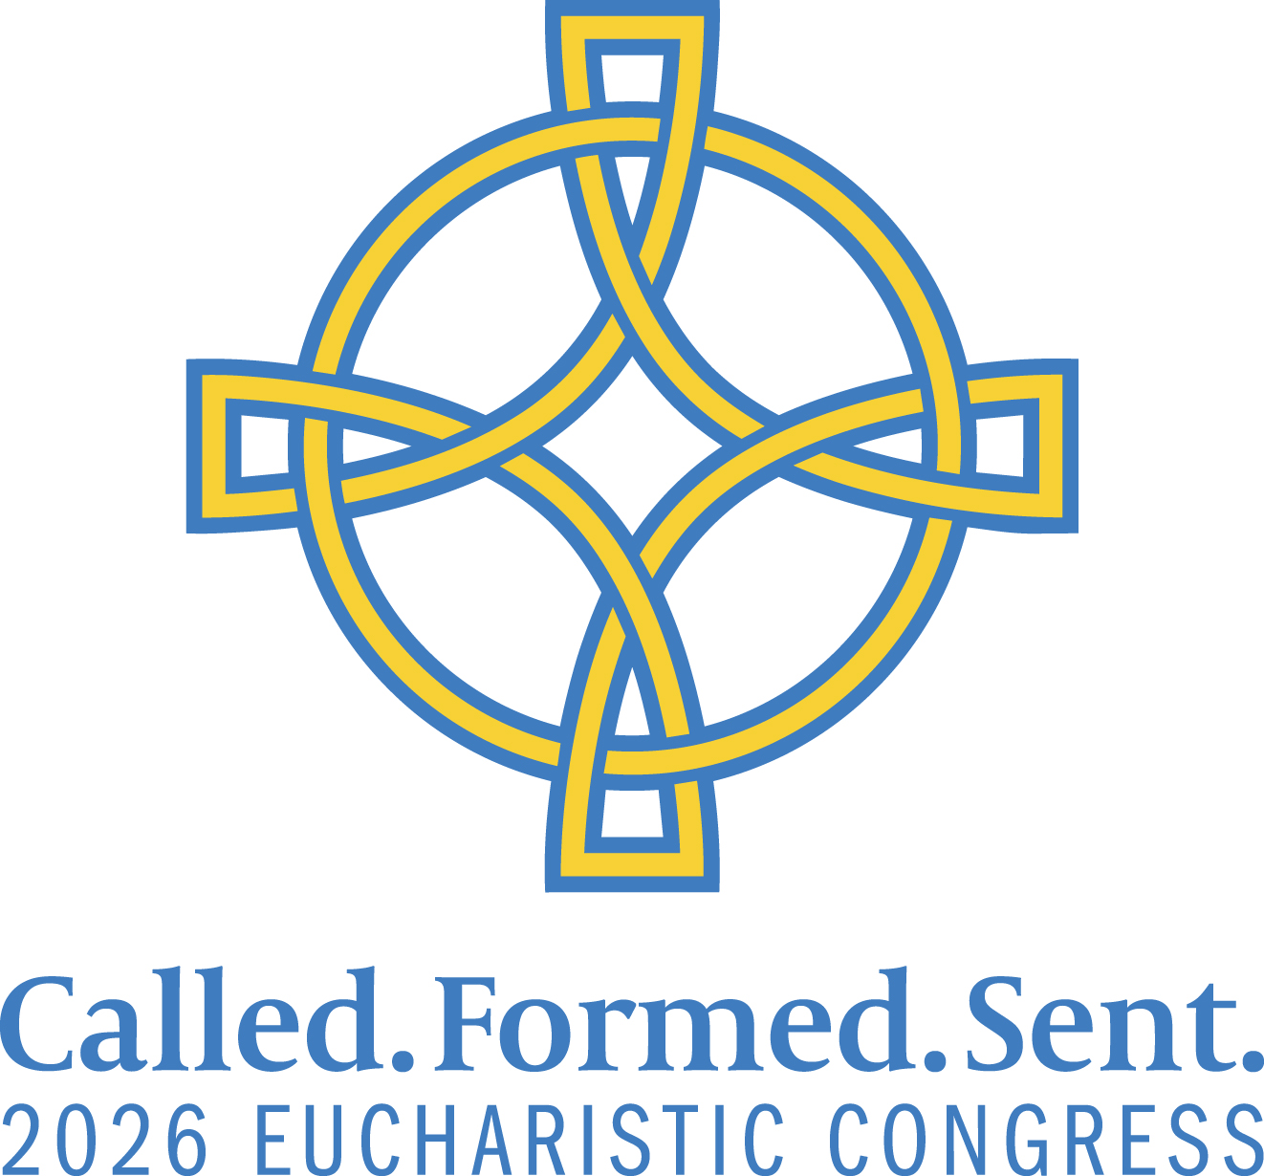

Jesus still calls ordinary people into extraordinary purpose.

Don’t miss the 2026 Eucharistic Congress Friday-Saturday, Sept. 11 & 12, at the Charlotte Convention Center as we come together with Catholics from across the Diocese of Charlotte and beyond! Be inspired by talented Catholic speakers and uplifting music, experience one of the largest Eucharistic processions in the U.S., and renew your relationship with Jesus. Drop in for an hour or come both days – it’s completely free and flexible! Details at www.GoEucharist.com.



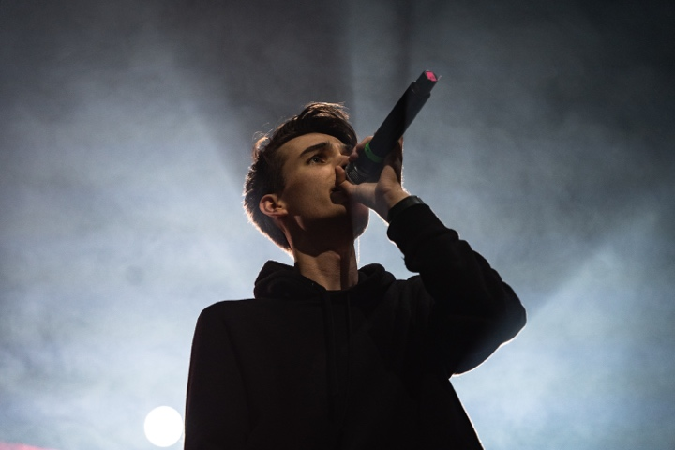

The Scally Brothers to open the 2026 Eucharistic Congress

Experience a weekend of inspiring music, praise and worship at the 2026 Eucharistic Congress Sept. 11&12 at the Charlotte Convention Center. Don’t miss the free Friday night concert at 8 p.m. featuring The Scally Brothers, the nationally acclaimed Christian pop duo known for their energetic performances and faith-filled music. Returning this year, The Vigil Project will lead pre-Mass worship, bringing their mission of enriching Catholic prayer through music. Also performing is Marieth Quintero, a Colombian soprano and liturgical musician with more than 24 years of experience in sacred music and parish ministry. Come celebrate your faith through powerful music and worship! GoEucharist.com

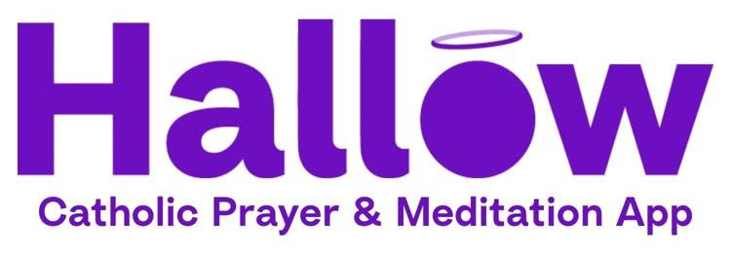

Come to the Eucharistic Congress and get 3 months of Hallow FREE – and meet its co-founder!

Every attendee at the 2026 Eucharistic Congress will receive three months of Hallow FREE, the world's leading Catholic prayer and meditation app. Meet Erich Kerekes, Hallow's co-founder, along with Mariana Lacouture and Nathan Crankfield from the Hallow team. Plus, hear from an inspiring lineup of Catholic speakers and digital evangelists, including Katie Prejean McGrady, Ana Munley and Marieth Quintero. It’s all part of this free, two-day event Sept. 11-12 at the Charlotte Convention Center. See the full line-up of speakers at GoEucharist.com.

Suggested Pulpit Announcement

I'd like to personally invite each of you to join me at the 2026 Eucharistic Congress on September 11-12 at the Charlotte Convention Center.

This is a one-of-a-kind opportunity for us to gather with thousands of Catholics from across our diocese to encounter Jesus in the Eucharist, grow in our faith, and be inspired by outstanding speakers, beautiful music, a Eucharistic procession through Uptown Charlotte, and opportunities for confession, prayer and fellowship.
I especially encourage you to join us for the closing Mass on Saturday afternoon with Bishop Michael Martin. Please note that this Mass fulfills your Sunday obligation, and because all of the priests of the diocese will be participating in the Congress, we will not celebrate our usual Saturday Vigil Mass here at the parish.
Whether you come for just an hour or spend the entire weekend, there's something for everyone – and admission is totally free.
Please see the bulletin or visit GoEucharist.com for the schedule and more information. I hope you'll join me for this special time together as a parish and diocesan family.

