**Suggested Bulletin Announcements**

(English)

**Rediscover hope. Renew your spirit. Walk with Christ.**

Don’t miss the 2025 Eucharistic Congress Friday-Saturday, Sept. 5 & 6, at the Charlotte Convention Center as we come together as *Pilgrims of Hope* with fellow Catholics from across the Diocese of Charlotte! Be inspired by dynamic Catholic speakers and uplifting music, experience one of the largest Eucharistic processions in the U.S., and find renewed hope in Christ through the Eucharist. Drop in for an hour or come both days – it’s totally free and flexible! Details at [www.YouBelong2025.com](http://www.YouBelong2025.com).

***\*\*\*\****

**Volunteer at the 2025 Eucharistic Congress**

Be part of something inspiring! Volunteer during the 2025 Eucharistic Congress on Sept. 5 & 6, 2025. Roles include procession assistance, speaker support, and greeting attendees. All Volunteers receive free parking, and Ushers and Youth Track Volunteers also receive a free T-shirt. Sign up at [www.goeucharist.com/get-involved](http://www.goeucharist.com/get-involved).

***\*\*\*\****

***Chris Stefanick***

**2025 Eucharistic Congress to feature Chris Stefanick**

The Eucharist reminds us of God’s love – especially in life’s hardest moments. Through his nonprofit, Real Life Catholic, Chris Stefanick has reached millions with his dynamic seminars, bestselling books, and impactful video series – all designed to help people discover and embrace the lives they were made for in Jesus Christ and His Church. Join him at the 2025 Eucharistic Congress Sept. 5 & 6 and be inspired to share your faith with joy and conviction. Drop in for an hour or come both days – it’s totally free and flexible! Details at [www.YouBelong2025.com](http://www.YouBelong2025.com).

***\*\*\*\****

***Father John Riccardo & ACTS XXIX***

**At the 2025 Eucharistic Congress: Mobilize for mission**

Most people have never been overwhelmed by the power of the Gospel, let alone surrendered their lives to Jesus. Yet there is no hope apart from Him, because no one else has done or can do what He has done. At the 2025 Eucharistic Congress (Sept. 5 & 6 at the Charlotte Convention Center), don’t miss a powerful message of hope from Father John Riccardo, executive director of ACTS XXIX and nationally known radio host, author and speaker. Details at [www.YouBelong2025.com](http://www.YouBelong2025.com).

***\*\*\*\****



***‘Carlo Acutis: Roadmap to Reality’***

**In a world losing itself to screens, teenage mystic Carlo Acutis saw beyond our social media-addicted society and offered an answer – if we’re willing to listen.**

“Carlo Acutis: Roadmap to Reality” explores the life of the first millennial saint while following teens on a phone-free pilgrimage to his tomb, immersing them in his story, his love for Jesus, and a search for meaning in the digital age. Experience this powerful new film at exclusive free screenings at the 2025 Eucharistic Congress Sept. 5 & 6. Details at [www.YouBelong2025.com](http://www.YouBelong2025.com).

***\*\*\*\****

***Matt Maher***

**Kick off your Congress experience with inspiring music and worship**

*2025 Eucharistic Congress Opening Concert with Matt Maher*

*Friday, Sept. 5, Charlotte Convention Center*

Get ready for an unforgettable night of praise and worship – culminating with Eucharistic Adoration – led by singer/songwriter Matt Maher, one of the most influential voices in Christian music today. A nine-time Grammy nominee and the songwriter behind beloved worship anthems like “Lord, I Need You” and “Your Grace Is Enough,” he brings to the stage both powerful music and a heart for worship.

The 2025 Eucharistic Congress Opening Concert is free, but seating is limited and first-come, first-served. Doors open at 5 p.m. and the concert starts at 7 p.m. Come early to secure your spot! (And don’t forget to invite your non-Catholic friends who love great praise and worship music to join you.) After the concert, stay for a free screening of “Carlo Acutis: Roadmap to Reality.” Food and drinks available for purchase, including cash bar.

Learn more at [www.YouBelong2025.com](http://www.YouBelong2025.com).

***\*\*\*\****

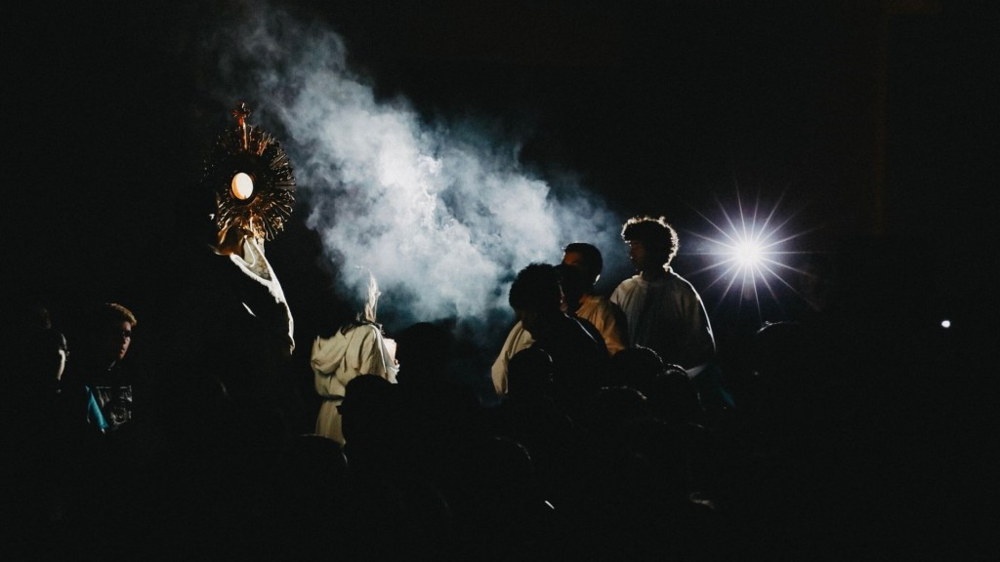

**Free Concert & Movie will open 2025 Eucharistic Congress**

Looking for a meaningful date night or a fun evening for the whole family? Kick off the 2025 Eucharistic Congress with an uplifting night of praise, worship, and inspiration on Friday, Sept. 5.

Internationally acclaimed Catholic artist Matt Maher will lead a powerful concert at 7 p.m., featuring worship favorites including “Lord, I Need You” and “Your Grace Is Enough.” The concert will culminate with Eucharistic Adoration.

Following the concert, don’t miss a free screening of “Carlo Acutis: Roadmap to Reality,” a moving look at the young “Millennial Saint.”

Doors open at 5 p.m. Seating is limited and first-come, first-served. Food and drinks available for purchase, including cash bar. Learn more at [www.YouBelong2025.com](http://www.YouBelong2025.com).

***\*\*\*\****

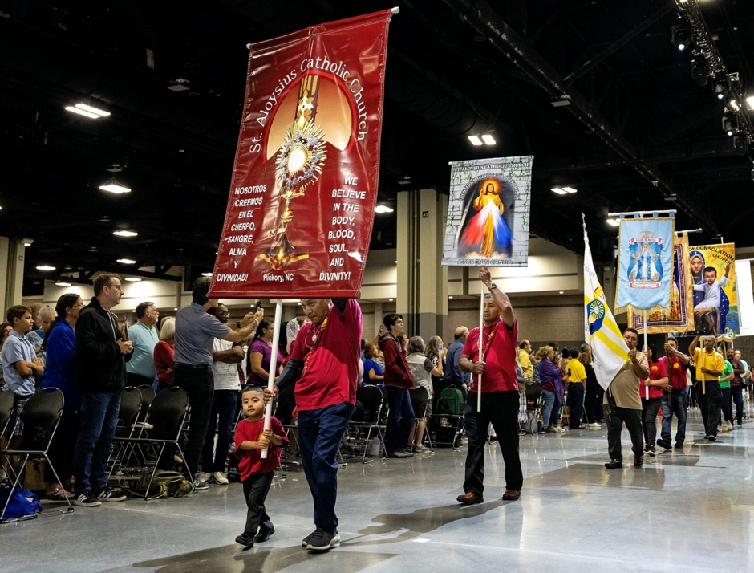

**2025 Eucharistic Congress: Walk with Christ as *Pilgrims of Hope***

Join thousands of fellow Catholics as *Pilgrims of Hope* in public witness of our faith in a Eucharistic Procession through Uptown Charlotte – one of the largest in the U.S. and a highlight of the 2025 Eucharistic Congress that you won’t want to miss! The Eucharistic Procession kicks off at 9 a.m. Saturday, Sept. 6, outside St. Peter Catholic Church on South Tryon Street and culminates inside the Charlotte Convention Center with a Holy Hour led by Bishop Michael Martin. Everyone is welcome – find details at [www.YouBelong2025.com](http://www.YouBelong2025.com) (click on Saturday Procession).

***\*\*\*\****

**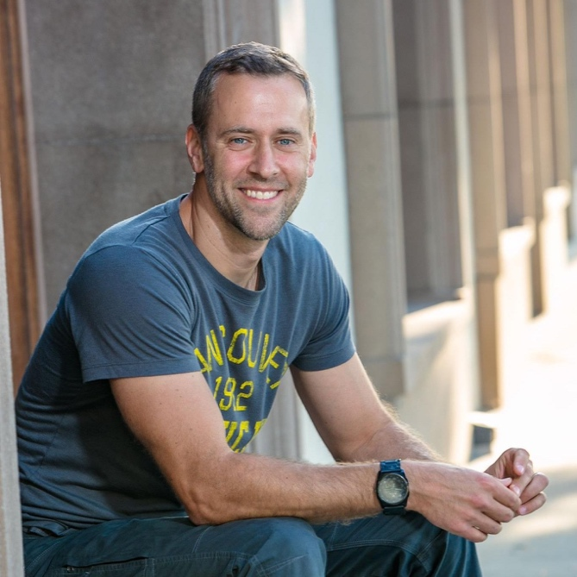  
*Chris Stefanick***

**2025 Eucharistic Congress: Attention, middle and high school students!**

The 2025 Eucharistic Congress will feature a special program just for you. Come hear from acclaimed speaker, author and TV host Chris Stefanick on Saturday, Sept. 6. You might know him from his Confirmation prep program, “Chosen,” but Chris has also reached millions with his dynamic seminars, bestselling books, and impactful video series. His goal is to help people discover and embrace the lives they were made for in Jesus Christ and His Church. See what he can inspire in you!

The MS/HS program will run from 12:30-3:30 p.m. Saturday. Consider staying for the closing Mass of the Eucharistic Congress at 5:30 p.m. as a family to hear Bishop Michael Martin preach. (This vigil Mass fulfills your Sunday obligation.)

The Eucharistic Congress will take place Friday-Saturday, Sept. 5 & 6, at the Charlotte Convention Center. The MS/HS program is free, but sign-ups are required. Get more info at [www.YouBelong2025.com](http://www.YouBelong2025.com).

***\*\*\*\****

**2025 Eucharistic Congress: Shop for unique Catholic merchandise**

The 2025 Eucharistic Congress offers unique Catholic artwork, Bibles and books, rosaries, statues and gifts – exceptional items you won’t find anywhere else! Save the date and plan to attend: Friday-Saturday, Sept. 5 & 6, 2025, at the Charlotte Convention Center. Get a sneak peak of the 2025 exhibitors and ministries and plan your shopping ahead of time at [www.YouBelong2025.com](http://www.YouBelong2025.com) (click on Exhibitors).